

Undergraduate Internship Report
Program: Bachelor of Engineering
Department: Computer Science and Engineering
Academic Year: 2022 – 2026

Internship Duration: JANUARY 2025- JULY 2025
Name of Student: Boddu Harshith
Register Number: 192210516
Batch: 2022 – 2026
Internship Organization: Codec Technologies
Supervisor in Company: Dr. Anurag Srivastava

1. Internship Completion Certificate
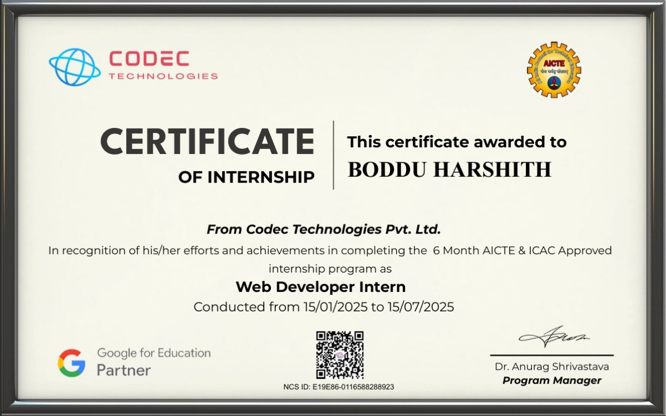

2. Student Declaration

I Boddu Harshith, a student of Bachelor of Engineering in the Department of Computer Science and Engineering, solemnly affirm that the internship experience documented in this report reflects my direct involvement in a formal organizational setting, actively engaged in industry-relevant operations.

During the internship period from 15/01/2025 to 15/07/2025, I was entrusted with tasks and responsibilities that were integral to the company’s ongoing functions. The insights and observations included herein are a true representation of the work culture, technical exposure, and professional interactions I encountered.

This report has been prepared based on actual experiences and contributions during my time with the organization. I have abided by the professional conduct expected of an intern and ensured that the contents of this document are factual, original, and aligned with the intended academic and industrial learning objectives.

Signature of the Student
Date: __________

3. Company Overview
Name of the Company:
CODEC Technologies
Nature of Business / Industry Sector: : Online Education & Technology Training
Brief History & Overview:
CODEC Technologies is an online learning and internship platform that provides practical training opportunities for students in various technical domains such as Web Development, Data Science, Artificial Intelligence, and Software Development. The organization focuses on improving students’ technical knowledge by offering hands-on project experience, industry-relevant training, and mentorship support. Through structured internship programs, CODEC Technologies helps students develop real-world skills and gain exposure to modern development technologies used in the software industry.
Key areas of Work
- Web Application Development– Developing web pages and basic web applications using HTML, CSS, and JavaScript while understanding the structure and behaviour of modern websites.
- User Interface Design– Creating responsive and user-friendly webpage layouts using styling techniques and responsive design principles.
- Frontend Development Practice– Working on frontend development tasks such as page layout creation, styling components, and improving visual presentation of web pages.
- Project Documentation and Learning– Documenting learning progress, understanding development workflows, and maintaining proper project structure during development.
4. Internship Role and Objectives
Internship Title/Designation:
Web Developer Intern
Objectives:
The primary objective of this study is to understand the fundamentals of web development in a comprehensive and structured manner. Web development serves as the foundation of the modern digital ecosystem, enabling individuals and organizations to create and maintain their presence on the internet. Learning these fundamentals involves understanding how websites function, how data flows between clients and servers, and how browsers interpret and render content. It also includes gaining familiarity with essential concepts such as domain names, hosting, and web protocols. By building a strong conceptual base, learners are better equipped to approach more complex topics in web development with confidence and clarity.
A significant goal of this learning process is to gain practical experience in core web technologies such as HTML, CSS, and JavaScript. HTML provides the structure of a webpage, CSS is responsible for its styling and layout, and JavaScript adds interactivity and dynamic behavior. Hands-on practice with these technologies allows learners to move beyond theoretical understanding and actually build functional web pages. This practical exposure is crucial because web development is a skill best learned by doing. Through continuous experimentation and practice, learners develop the ability to translate ideas into working digital solutions.
Understanding how websites are designed and developed is another essential objective. This involves learning the complete lifecycle of web development, starting from planning and designing to coding and deployment. It includes creating wireframes, choosing appropriate layouts, organizing content effectively, and ensuring smooth navigation for users. Additionally, it involves understanding the importance of user experience (UX) and user interface (UI) design principles. A well-designed website is not only visually appealing but also intuitive and easy to use, which enhances user satisfaction and engagement.
Developing responsive and user-friendly web interfaces is a critical focus area in modern web development. With the increasing use of mobile devices, it is essential for websites to adapt to different screen sizes and resolutions. Responsive design techniques, such as flexible layouts, media queries, and fluid images, ensure that websites function properly across various devices. Creating user-friendly interfaces also involves considering accessibility, readability, and ease of navigation. This objective emphasizes the importance of designing websites that cater to a diverse range of users and provide a seamless browsing experience.
Improving debugging and problem-solving skills is another major objective of this study. Web development often involves encountering errors and unexpected behaviors in code. Learning how to identify, analyze, and fix these issues is an essential skill for any developer. Debugging requires patience, logical thinking, and attention to detail. By practicing problem-solving techniques and using debugging tools, learners become more efficient in resolving issues. This not only improves the quality of their work but also builds confidence in their ability to handle complex challenges.
Understanding real-world software development workflows is also an important goal. This includes learning how professional developers plan, build, test, and maintain web applications. It involves familiarity with tools such as version control systems, code editors, and collaboration platforms. Learners gain insight into how teams work together on projects, manage code changes, and ensure consistency in development. This objective helps bridge the gap between academic learning and industry practices, preparing learners for real-world work environments.
Another important aspect of web development is learning how to structure and organize code effectively. Writing clean, readable, and maintainable code is a crucial skill that enhances collaboration and long-term project sustainability. Proper code organization makes it easier to understand, debug, and update applications. This objective encourages the adoption of best practices such as consistent naming conventions, modular design, and proper documentation. By focusing on code quality, learners can create applications that are not only functional but also easy to maintain and scale.
The study also aims to develop creativity and innovation in web design. Web development is not just about writing code; it is also about creating visually appealing and engaging user experiences. Learners are encouraged to experiment with different design styles, layouts, and interactive elements. This creative approach helps in developing unique and attractive websites that stand out in a competitive digital landscape. By combining technical skills with creative thinking, learners can produce designs that effectively communicate ideas and capture user attention.
Another objective is to understand the importance of performance optimization in web development. Fast-loading websites provide a better user experience and are more likely to retain visitors. This involves optimizing images, minimizing code, and reducing server response times. Learners also explore techniques such as caching and efficient resource management to improve performance. By focusing on optimization, developers can ensure that their websites run smoothly and efficiently, even under heavy usage.
Finally, the study emphasizes continuous learning and adaptation in the field of web development. Technology is constantly evolving, and new tools, frameworks, and best practices are introduced regularly. Developers must stay updated with these changes to remain relevant and competitive. This objective encourages a mindset of lifelong learning, where individuals continuously seek to improve their skills and expand their knowledge. By staying curious and adaptable, learners can successfully navigate the ever-changing landscape of web development and build a successful career in the field.

5. Technologies & Tools
During my internship as a Front-End Web Developer at Codec Technologies, I had the opportunity to work extensively with a wide range of modern front-end tools, technologies, and frameworks that are widely used in the web development industry today. This experience provided me with a strong practical foundation and allowed me to apply theoretical knowledge to real-world projects. The tools and technologies I used not only enhanced my technical skills but also improved my ability to design and develop responsive, interactive, and user-friendly web interfaces. The exposure to industry-standard practices helped me understand how professional front-end development workflows operate in real-time environments. This section elaborates in detail on the various front-end technologies I worked with and how each contributed to my learning and development during the internship.
The core of front-end development begins with HTML5, which served as the structural foundation for all the web pages I created. HTML5 allowed me to design well-structured and semantically meaningful web pages. I used various tags such as headers, sections, articles, forms, buttons, and image containers to build organized layouts. One of the key learnings was understanding the importance of semantic elements, which improve accessibility and search engine optimization. By structuring content properly, I ensured that the web pages were not only visually appealing but also easy to navigate and understand for users and search engines alike. HTML5 also enabled me to integrate multimedia elements such as images, audio, and video seamlessly into the web pages, enhancing the overall user experience.
CSS3 played a crucial role in transforming the basic structure created with HTML into visually appealing and attractive web interfaces. Through CSS, I applied styling such as colors, fonts, spacing, alignment, and layouts. I explored advanced CSS concepts like Flexbox and Grid, which allowed me to create complex and responsive layouts with ease. Flexbox was particularly useful for aligning elements in a flexible and efficient manner, while CSS Grid helped in designing multi-dimensional layouts. Additionally, I used media queries to make the websites responsive, ensuring they adapt smoothly to different screen sizes such as desktops, tablets, and mobile devices. I also experimented with animations and transitions, which added a dynamic and engaging feel to the web pages.
JavaScript was the backbone of interactivity in the web applications I developed. It allowed me to create dynamic features and enhance user engagement. I implemented functionalities such as form validation, event handling, and DOM manipulation. For example, I worked on validating user input in forms to ensure data accuracy before submission. I also handled events such as button clicks, mouse movements, and keyboard inputs to create interactive experiences. Through JavaScript, I gained a deeper understanding of programming concepts such as variables, functions, loops, conditionals, and arrays. I also explored modern JavaScript features introduced in ES6 and beyond, such as arrow functions, template literals, destructuring, and modules. These features made the code more concise, readable, and efficient.
Another important aspect of JavaScript that I explored during my internship was asynchronous programming. I learned how to handle asynchronous operations using promises and async/await. This was particularly useful when working with APIs and fetching data from external sources. By understanding asynchronous behavior, I was able to create smoother user experiences without blocking the execution of other parts of the application. This knowledge is essential in modern web development, where real-time data updates and API integrations are common.
To accelerate development and maintain consistency in design, I used Bootstrap, a widely adopted CSS framework. Bootstrap provided pre-designed components such as navigation bars, buttons, cards, modals, and forms, which significantly reduced development time. It also offered a responsive grid system that made it easier to design layouts that adapt to different screen sizes. Using Bootstrap, I was able to quickly prototype and build user interfaces without starting from scratch. It also helped me understand the importance of consistency in design and how reusable components can improve efficiency in development.
In addition to Bootstrap, I also worked with Tailwind CSS, a utility-first CSS framework that offers a different approach to styling. Instead of relying on predefined components, Tailwind allows developers to apply utility classes directly within HTML to style elements. This approach gave me greater control over the design and helped me create highly customized user interfaces. I learned how to use Tailwind’s utility classes for spacing, typography, colors, and layout. This experience improved my ability to think in terms of design systems and develop interfaces that are both consistent and flexible.
One of the most significant technologies I worked with during my internship was React.js, a powerful JavaScript library for building user interfaces. React introduced me to the concept of component-based architecture, where the user interface is divided into reusable and independent components. This approach made the code more organized and easier to maintain. I learned how to create functional components and manage data using props and state. React’s declarative nature allowed me to describe how the UI should look based on the data, making development more intuitive.
State management in React was another important concept I explored. Using hooks such as useState and useEffect, I was able to manage and update the state of components efficiently. This enabled me to create dynamic and interactive applications where the UI updates automatically based on user actions or data changes. I also learned how to handle side effects such as data fetching and event listeners using useEffect. These concepts are essential for building modern single-page applications.
React Router was used to implement navigation within the applications. It allowed me to create a seamless browsing experience by enabling client-side routing. Instead of reloading the entire page, React Router updates only the necessary components, making the application faster and more efficient. I learned how to define routes, create navigation links, and handle dynamic routing. This experience helped me understand how single-page applications function and how to manage navigation effectively.
Another key aspect of front-end development that I focused on was responsive design. With the increasing use of mobile devices, it is essential for websites to provide a consistent experience across different screen sizes. I used a combination of CSS techniques, Bootstrap’s grid system, and Tailwind utilities to create responsive layouts. I tested the applications on various devices and screen sizes to ensure optimal performance and usability. This practice helped me understand the importance of mobile-first design and how to prioritize content for smaller screens.
User experience (UX) and user interface (UI) design principles were also an integral part of my learning. I focused on creating interfaces that are intuitive, easy to navigate, and visually appealing. This involved selecting appropriate color schemes, typography, and layout structures. I also ensured that interactive elements such as buttons and forms were user-friendly and accessible. By considering the needs and expectations of users, I was able to design applications that provide a positive and engaging experience.
Debugging and testing were essential parts of the development process. I used tools such as Visual Studio Code for writing and managing code efficiently. Its features, including IntelliSense, extensions, and integrated terminal, improved my productivity. For debugging, I relied on browser developer tools, which allowed me to inspect elements, analyze styles, and identify JavaScript errors. These tools helped me troubleshoot issues quickly and ensure that the applications function correctly.
Google Chrome Developer Tools played a significant role in front-end debugging. I used the Elements panel to inspect and modify HTML and CSS in real time, the Console to view error messages and debug JavaScript code, and the Network tab to monitor resource loading and API calls. These tools provided valuable insights into how the application behaves and helped me optimize performance. Additionally, I used React Developer Tools to analyze component structures and state, which made debugging React applications more efficient.
Another important aspect of my internship was learning how to write clean and maintainable code. I followed best practices such as proper indentation, meaningful variable names, and modular code structure. Writing clean code not only makes it easier to understand but also simplifies debugging and future enhancements. I also used tools like Prettier and ESLint to maintain code consistency and enforce coding standards. These practices are essential for working in team environments and maintaining high-quality codebases.
Collaboration and communication were also key components of my internship experience. Although my primary focus was on front-end development, I worked closely with team members to ensure that the user interface aligned with project requirements. I participated in discussions, shared ideas, and received feedback on my work. This collaborative environment helped me improve my communication skills and understand the importance of teamwork in software development.
Time management and task organization were crucial for successfully completing assigned work. I learned how to break down complex tasks into smaller, manageable steps and prioritize them effectively. This approach helped me stay organized and meet deadlines consistently. By managing my time efficiently, I was able to balance learning new concepts with completing project tasks.
Overall, my internship at Codec Technologies provided me with valuable hands-on experience in front-end web development. I gained a deep understanding of core technologies such as HTML, CSS, JavaScript, Bootstrap, Tailwind CSS, and React.js. I also developed important skills such as problem-solving, debugging, responsive design, and code organization. This experience not only strengthened my technical abilities but also prepared me for real-world challenges in the field of web development. It has laid a strong foundation for my future growth as a front-end developer and has motivated me to continue learning and improving my skills in this ever-evolving domain.
6. Learning Outcomes

The internship experience at Codec Technologies has been transformative, offering me in-depth exposure to the inner workings of a real-time software development environment. One of the most significant outcomes was the extensive exposure to the Software Development Life Cycle (SDLC), which included phases such as requirement gathering, designing scalable solutions, coding both front-end and back-end modules, testing functionalities, debugging issues, and preparing components for deployment. This hands-on experience provided clarity on how development happens in an industry setting, which is far more dynamic and fast-paced compared to academic assignments. I gained a better appreciation of the iterative development model and how changes from client feedback are incorporated throughout the project lifecycle.
A particularly enriching learning aspect was the use of Agile methodology and SCRUM practices. Daily stand-up meetings, sprint planning, and retrospectives gave me practical insight into how modern development teams stay coordinated and productive. I learned how each sprint is used to incrementally build the product, and how breaking large tasks into smaller modules ensures that deadlines are met without compromising quality. Agile also helped me understand the importance of client feedback, adaptability to changes, and the value of a team-driven development model. Working with task boards and sprint workflows using tools like Trello and GitHub Projects helped improve my organizational discipline and professional accountability.
From a technical perspective, this internship significantly enhanced my proficiency in both front-end and back-end development. On the front-end side, I developed a strong command over HTML5, CSS3, and JavaScript ES6+. I built user interfaces using Bootstrap and Tailwind CSS and was able to use React.js to create component-based designs, manage state, and route pages dynamically. This hands-on coding experience went far beyond classroom learning and equipped me with the ability to build responsive and functional interfaces independently.
One of the most insightful outcomes of my internship at Codec Technologies was gaining a strong understanding of how industrial workflows function in the software development ecosystem. Unlike academic projects, where assignments are often executed in isolation or within small groups, real-time projects in a corporate setting demand a structured, well-documented, and collaborative approach. My experience working within the Web Development Division gave me practical exposure to how professional teams operate, plan, and execute large-scale software projects using a variety of industry-standard tools and frameworks.
At the core of the workflow was task assignment and tracking, which was managed using project management tools such as Trello and GitHub Projects. These platforms helped divide project requirements into manageable tasks, each tagged with clear objectives, deadlines, and priorities. We used boards with swimlanes such as “To Do,” “In Progress,” “Review,” and “Done” to track the flow of work. This not only gave clarity on my individual responsibilities but also enabled transparency across the team. Regular updates were maintained for each card, which helped mentors and team members assess progress without constant follow-ups. I learned how task planning is an essential skill in the industry, and how breaking down high-level goals into microtasks helps avoid bottlenecks and ensure steady progress.
A major part of our collaborative workflow was the use of version control systems, primarily Git and GitHub. Initially, managing version control in a team setting posed a steep learning curve. However, with time and guidance from senior developers, I became proficient in using Git commands and understanding workflows involving branches, forks, merge requests, and pull requests. I learned to create feature-specific branches, test code locally, and push it to remote repositories after proper documentation. Code reviews were an integral part of this system, where every pushed change was subject to scrutiny and feedback by team leads. Through these reviews, I not only improved my code quality but also developed a habit of writing cleaner, well-commented, and more modular code. I also learned how merge conflicts are resolved and how tools like GitHub’s comparison viewer assist in spotting code differences during integration.
Additionally, code review and feedback sessions provided a platform for continuous learning. These sessions allowed me to understand coding patterns, optimization strategies, and real-world logic that go beyond textbook approaches. They also cultivated a habit of accepting criticism constructively and understanding the rationale behind each suggested improvement. Sprint planning and review meetings were held at the beginning and end of every development cycle, where completed tasks were evaluated, upcoming goals were discussed, and challenges were addressed. These iterative discussions helped me understand the Agile methodology in depth and exposed me to real-time SCRUM practices, which are now widely adopted across software industries globally.
Another critical aspect of industrial workflow I experienced was the emphasis on clean code practices and documentation. Each function, module, or component I developed had to be easily understandable and reusable. I was expected to follow the company’s style guidelines for naming conventions, indentation, and modularity. This was essential not only for code maintainability but also to ensure that others on the team could build upon or debug the modules I created. We were encouraged to write JSDoc comments for functions and include detailed README files when delivering standalone modules. This kind of discipline helped me understand that writing code is only one part of the job—making it understandable and maintainable is equally important.
Feedback from Supervisor:
The feedback from my supervisor reflected the progress I made throughout the internship. I was appreciated for proactively resolving technical issues, demonstrating a willingness to explore solutions independently, and maintaining a positive attitude even in complex situations. My supervisor also commended my growth in collaboration and communication, especially my ability to work effectively in a team setting using GitHub. I received encouraging feedback on the quality, consistency, and structure of my code, which had improved significantly by the end of the internship.

Overall, the challenges I encountered during the internship helped shape me into a more confident and competent developer. They taught me how to approach problems methodically, seek help when necessary, and apply theoretical knowledge to practical contexts. These experiences have prepared me to tackle future industry challenges with a strong problem-solving mindset and professional resilience.
7. Software Development Life Cycle (SDLC) Followed During Internship

During my internship, I understood the basic phases of the Software Development Life Cycle (SDLC) used in web development projects.
- Requirement Analysis – In this phase, the requirements of the web application were clearly identified. I understood the purpose of the project, identified the target users, and analysed the necessary features such as interactive user interfaces, dynamic components, form handling, and API integration. Both functional and non-functional requirements were considered to ensure clarity before starting development.
- System Design – After analysing the requirements, the system design phase was carried out. In this stage, the overall structure of the web application and the layout of the user interface were planned. Different sections of the application such as navigation menus, content areas, and interactive UI elements were designed. The focus was on creating a clean, responsive, and user-friendly interface to improve the overall user experience.
- Implementation (Coding Phase) – This phase involved the actual development of the application. During this stage, I worked on developing different components of the web application. The user interface was created using HTML, CSS, and JavaScript, and dynamic behaviour was implemented where required. I also practiced writing structured code, organizing project files properly, and ensuring that the application functions correctly according to the requirements.
- Testing Phase – In the testing phase, the application was evaluated to ensure that it worked correctly without errors. Functional testing was performed to verify that all elements such as buttons, forms, and navigation components worked as expected. Browser developer tools were used to identify and debug errors. The application was also tested for responsiveness to ensure it worked properly on different screen sizes.
- Deployment and Maintenance – Although the internship mainly focused on development activities, I gained basic knowledge about deployment practices and version control systems. I learned how developers manage code using Git and GitHub, track changes, and maintain project versions. This helped me understand how applications are updated and maintained in real-world software development environments, as well as the importance of proper documentation and collaboration
within a development team.
8. Implementation Results
Developed a Car Rental Website.

Code Implementation:
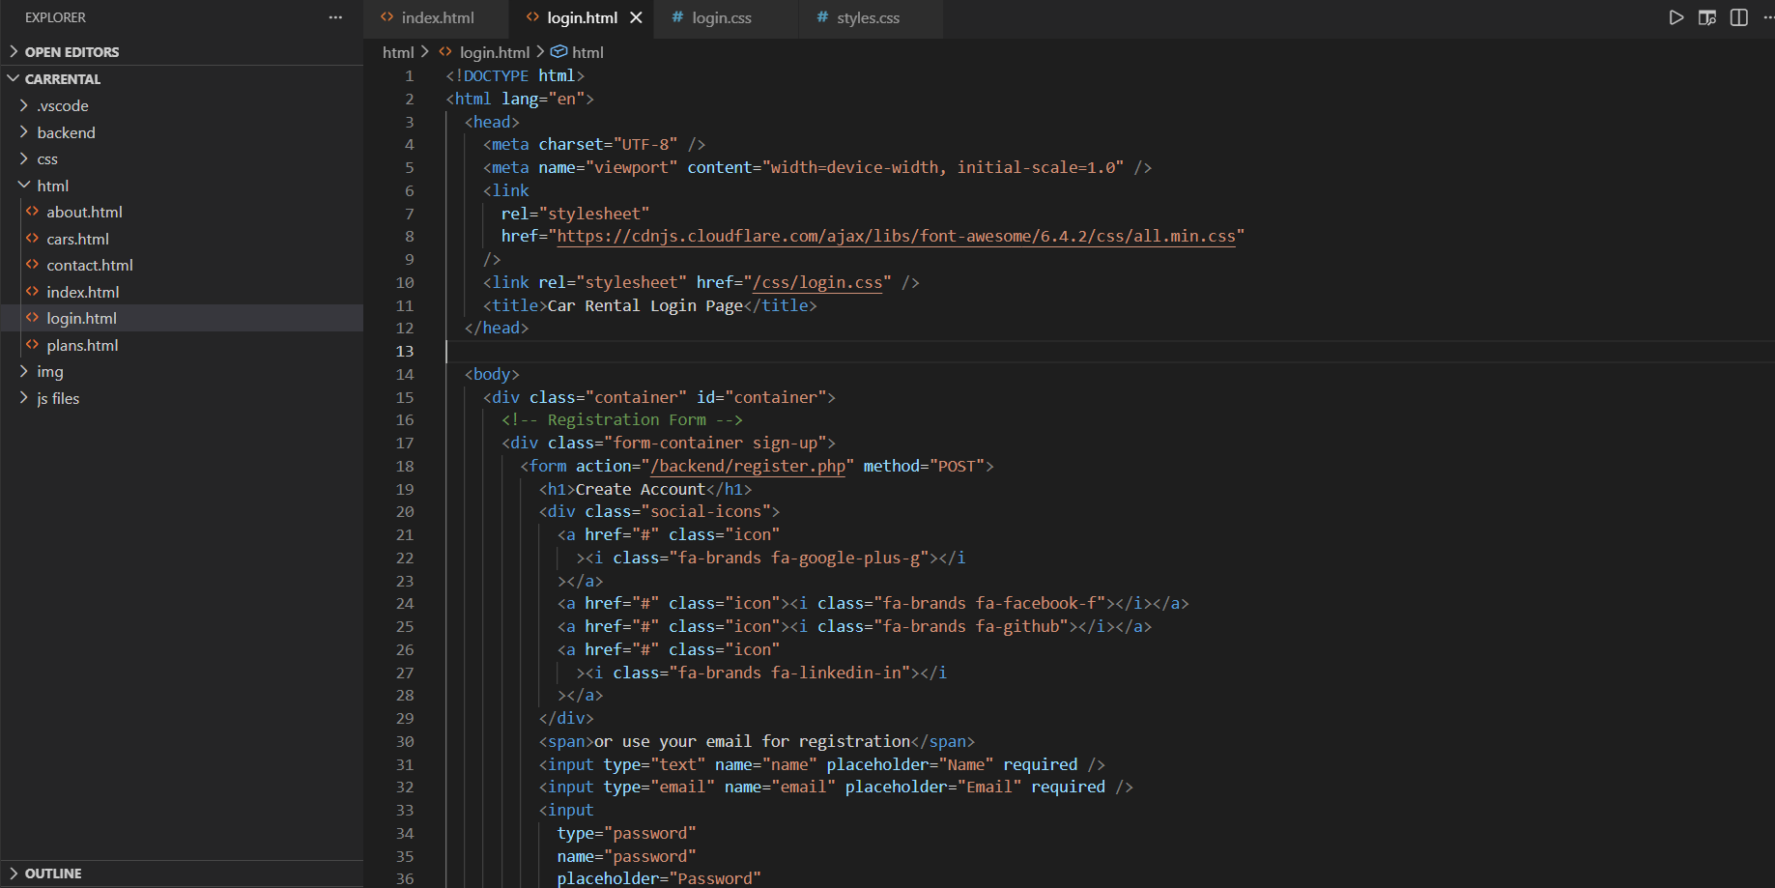

Login Page: 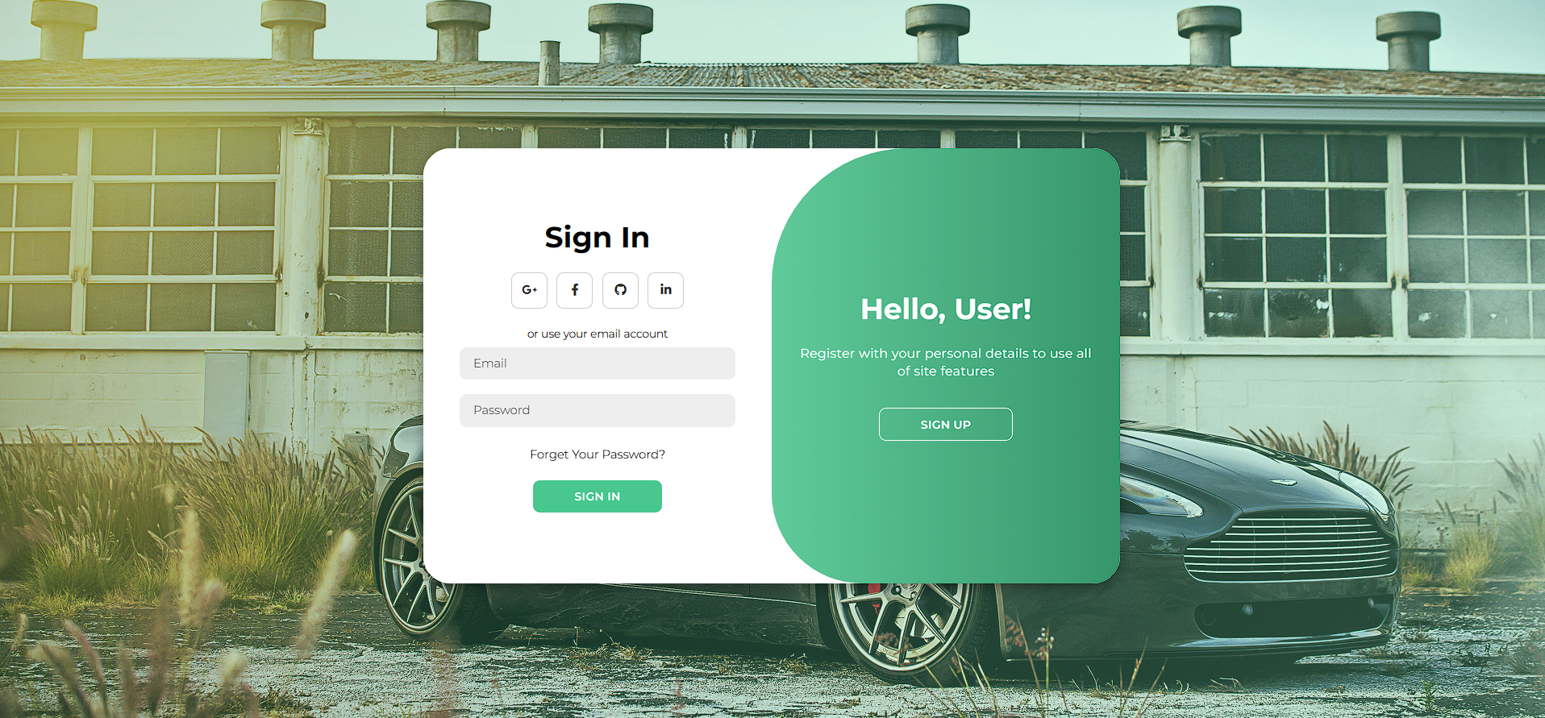

Home Page:
Contact us :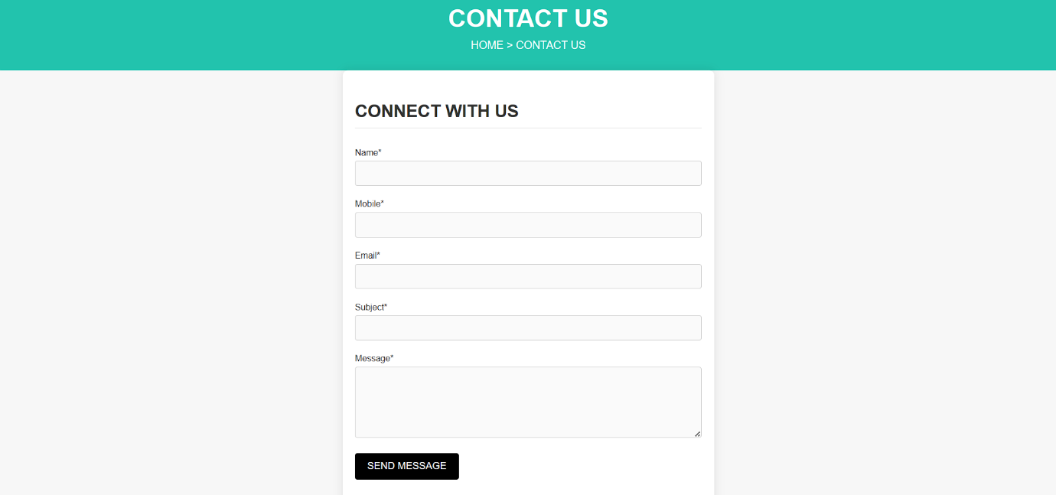

Pick Your Wheels:
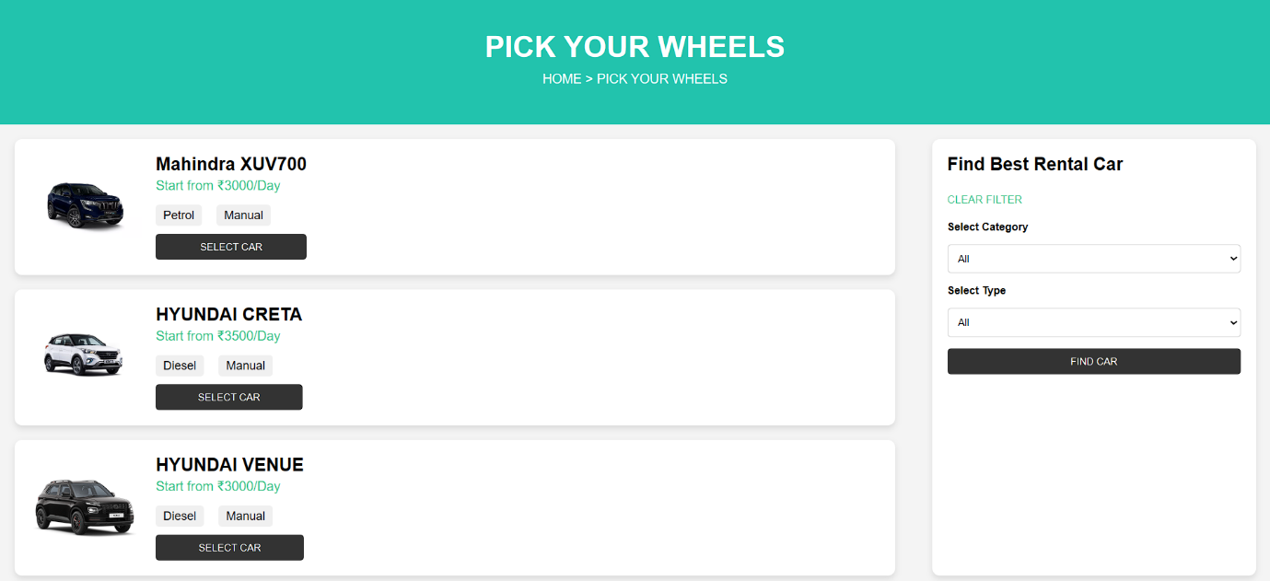
Our Plans:
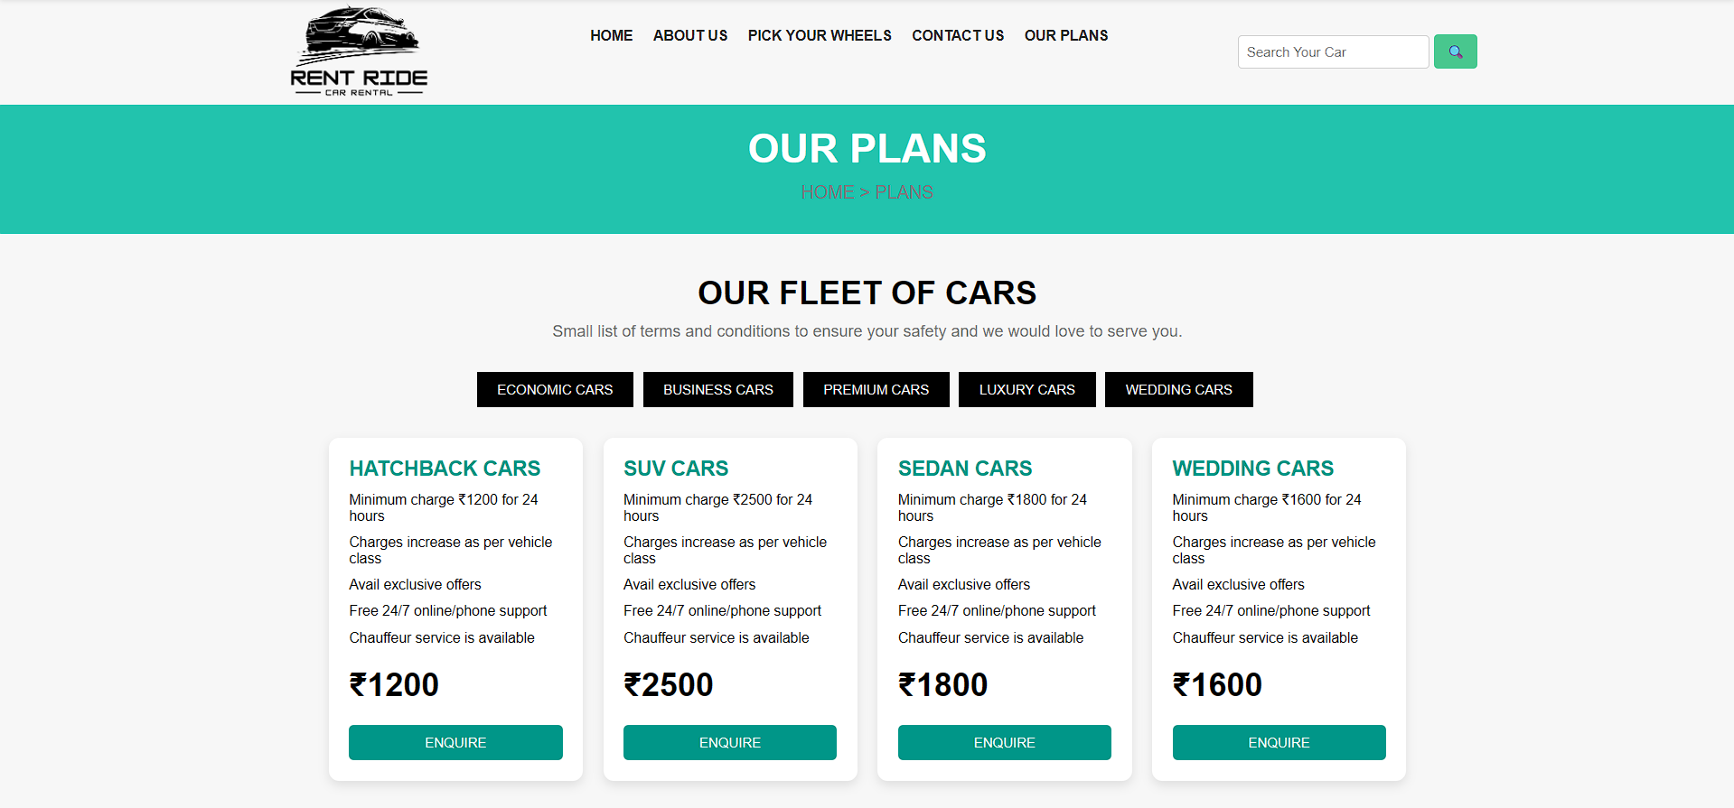

9. Overall Experience
The Web Development Internship at CODEC Technologies was a valuable learning experience that helped me gain practical knowledge in frontend web development. During this internship, I learned how to build basic web pages, design responsive layouts, and understand the workflow of real-world web development .This internship helped improve my technical knowledge, coding skills, and understanding of software development practices. It also strengthened my confidence in applying theoretical knowledge in practical development environments, which will be beneficial for my future career in software development.
10.Faculty Mentor’s Remarks
This is to certify that the internship report submitted by Boddu Harshith has been reviewed and it is evident that the internship was undertaken at a bonafide organization. The work documented is satisfactory and relevant to the student’s field of study.
Faculty:
Signature:
Date:

